For inequality, we use the xy plane. For given inequality the corresponding solution has all (\textcolor{primary}{x},y) points. Whereas x,y\in R.

Now, identify the point by putting \textcolor{primary}{x=-4} and y=0 such that (\textcolor{primary}{-4},0).

Compare given inequatily \textcolor{secondary}{a}\times {\textcolor{primary}{x}}+b \times y \leq \textcolor{tertiary}{c} with {\textcolor{primary}{x}} \leq \textcolor{tertiary}{-4}, so we have:

\textcolor{secondary}{a=1}

b=0

\textcolor{tertiary}{c=-4}

Use the corresponding equation of the line to get equation of line for given function:

\textcolor{secondary}{a}\times {\textcolor{primary}{x}}+b \times y = \textcolor{tertiary}{c}

\textcolor{primary}{x}=\textcolor{tertiary}{-4}

Now, plot the given point and line on \textcolor{primary}{x} and y plane.

Shade the region \textcolor{primary}{x}\leq \textcolor{tertiary}{-4} as shown below:

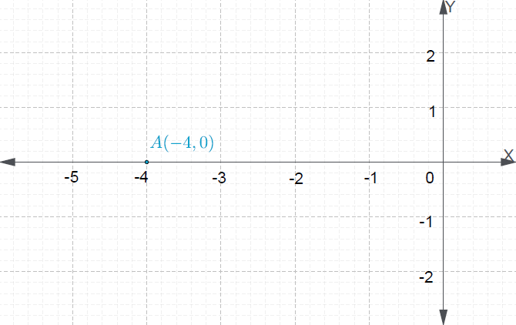

Plot point \textcolor{primary}{(-4,0)} on the graph.

Plot the \textcolor{primary}{x=-4} line on graph.

Shade the region x\leq -4.

The graph of x\leq -4 is shaded above.